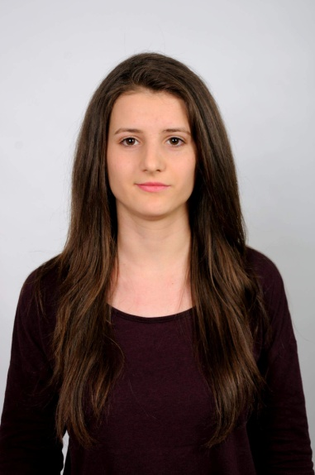**Name:** Teodora Branimirova Yankova

**Email:** [teodorayankova1@gmail.com](mailto:teodorayankova1@gmail.com)

**Data of Birth:** 11-06-1996

**Address:** Bl.9, Student city, Sofia 1770, Bulgaria

**Phone:** +359 883 306 156

**Nationality:** Bulgarian

**Driving license:** B category

**LinkedIn profile:** https://www.linkedin.com/in/teodora-yankova-bb9267115/

**EDUCATION:**

2015-2019 : University of National and World Economy

* Intellectual Property and Business 2017-2019
* Economics with Foreign Language Education with Business (English) 2015-2017

2010-2015: Foreing Language high school

* English
* German

**Language Proficiency:**

|  |  |  |  |  |
| --- | --- | --- | --- | --- |
| **Language** | Listening | Reading | Speaking | Writing |
| English | Very good | Very good | Very good | Very good |
| German | Good | Good | Good | Good |

**Computer tools:**

* Microsoft office:
* Word
* Excel
* Power Point
* Access

**Personal activity:**

* Tennis
* Hiking
* Jogging
* Aerobics